

SPONSOR FORM

CheckyourchoicesbelowPrice

____PLATINUM SPONSOR $1000

____GOLD SPONSOR $500

____SILVER SPONSOR $100

TOTAL_______

______________________________________________

Name

**_____________________________________________**

CompanyName

**_____________________________________________**

Address

**_____________________________________________**

Address

**_____________________________________________**

Email

**______________________________________________________________________**

# REGISTRATION FORM

$150 per person

# _______________

1. ________________
2. ________________
3. ________________

Registration Fee Totals ___________

**Please return Registration Form**

**by August 31, 2023**

*Please make checks payable to* **FARA, or**

**Venmo to @EricJamieson**

**MAIL TO**

**Eric Jamieson**

**7 Marshall Rd**

**Stoneham, Ma 02180**

***For More Info:***

Adam Stanieich Erin O’Neil

339-221-0229 617-605-5555

apstan05@ lana3158@

[gmail.com](http://gmail.com) aol.com

SPONSOR OPTIONS

**Platinum Sponsor $1000**

* + **One golf foursome, Golf gifts**
  + **Company Tee sign**

**Gold Sponsor $500**

* + **Golf Gift, T-Sponsor sign**

**Silver Sponsor $100**

* + **T-Sponsor sign**

**All other donations greatly appreciated ____________**

**Special Thanks to our Sponsors**

New England

Orthodontic Lab

**O.K. Engineering Inc.**

Proceeds to benefit FARA

September 7, 2014

Windham Country Club

1 Country Club Rd

Windham, NH 03087

37th Annual

Fuzzy Buzzy

Charity Golf Tournament

**September 10, 2023**

[www.fuzzybuzzygolf.org](http://www.fuzzybuzzygolf.org)

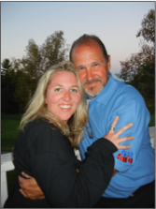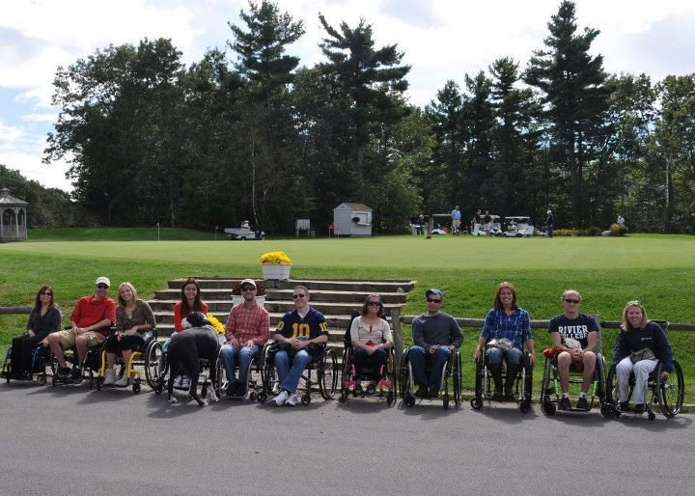

Charity Golf

Tournament

Tournament

FuzzyBuzzy

Proceeds to benefit FARA

September 10, 2023

Windham Country Club

1 Country Club Rd

Windham, NH 03087

# **FRIEDREICH’S ATAXIA**

For the 20th year we will be supporting the Friedreich’s Ataxia Research Alliance (FARA).

This is a foundation in need of contributions to help raise awareness and find a cure for the neuromuscular disease. My niece, Erin O’Neil, who is very special to me and my family, has been afflicted with this illness. In the last 19 years we have raised more than $300,000.00

DIRECTIONS

Windham Country Club

1 Country Club Rd

Windham, Nh 03087

From Boston: Rt 93 N Take exit 3,

bottom of ramp turn left RT 111 W. 1.7 mi. turn right onto Church Rd. Turn right on N. Lowell Rd.

.5 mi turn left on Londonderry Rd. .3 mi left on Country Club Rd.

# SCHEDULE OF EVENTS

**September 10, 2023**

**11:30 to 12:30 pm**

Registration

**1:00 pm**

Shotgun Start

Scramble, Best Ball format

**Immediately**

**following Golf:**

Cash Bar, Dinner,

Prizes, & Raffles